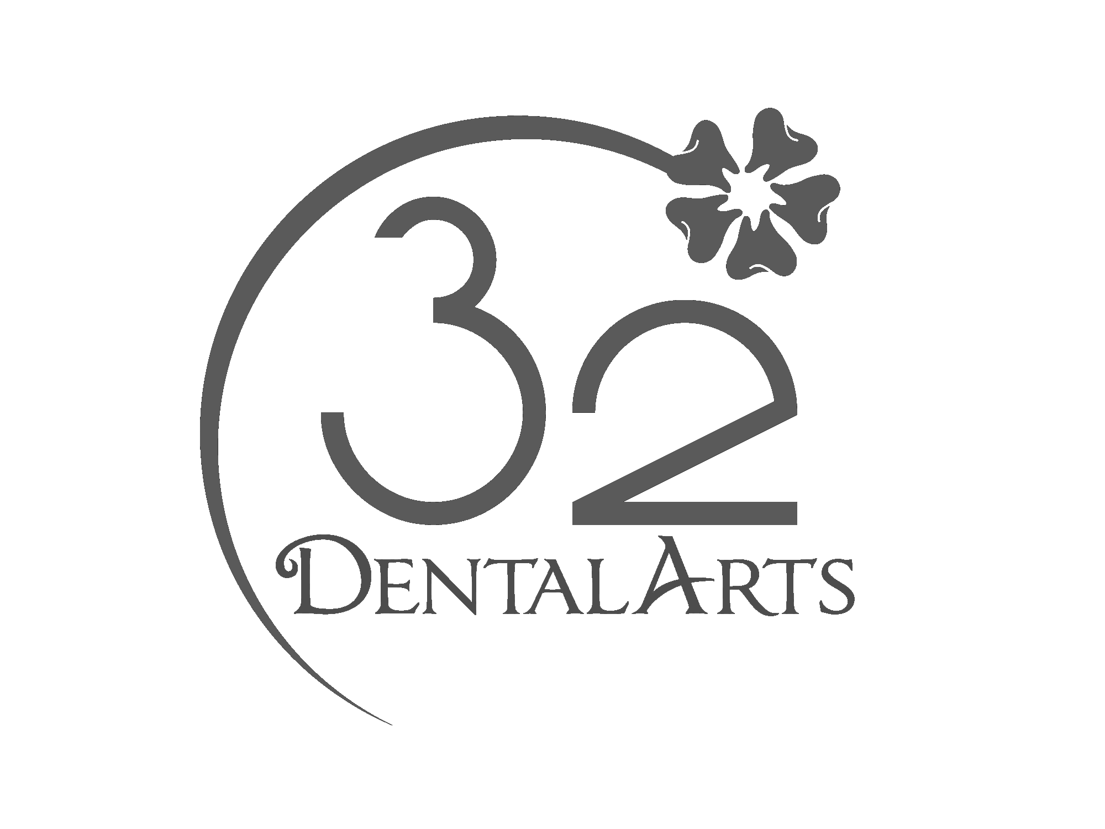 CONSENT TO PARTICIPATE IN A VIRTUAL CONSULT

The purpose of this form is to get your permission for you to access your dentist and participate in a virtual consult also known as “teledentistry”. This system allows your dentist, Dr. Barakat, to view your records electronically and possibly set up a live video session with you and make recommendations about your treatment. She could also review your records and other electronic communications with you and determine the best course of action for your dental care.

Our dental practice will be using the platform Teledent/Mouthwatch for remote communication technology to conduct problem-focused evaluations/re-evaluations virtually, and certain urgent and emergent dental problems to help manage your oral health problem and to determine whether you have a condition that requires immediate in-office treatment. During the current pandemic the federal government announced that it will not enforce HIPAA regulations (privacy for health records) in connection with medical and dental offices’ good faith provision of medical or dental services using non-public facing audio or video remote communications services. In spite of this, we still value your privacy and take your dental and medical record confidentiality very seriously and therefore, chose to use a HIPAA compliant encrypted platform that we can safely use even after the Covid -19 pandemic is over.

The benefit of a virtual consultation is that you may access and discuss your care with Dr. Barakat during times that our office is closed or if you are unable to travel to our office. However, a visit to a dental office and a face to face examination by a dentist may still be needed.

Certain major dental plans have announced that they will reimburse dental offices for conducting such remote evaluations, and we will submit claims in connection with them. Our dental office is using one or more of the permitted modalities (ie. either audio or audio/video) for remote transmission of information to conduct limited problem focused evaluations. While entirely adequate in the vast majority of cases for such limited purposes, these evaluations may not reveal conditions that would be discovered during an office visit or through the use of specialized teledentistry technology. Please indicate your understanding of and informed consent to these terms, which will be in effect until the government rescinds its suspension of these HIPAA requirements, by typing your name in the space provided and returning via email to this office.

__________________________________ _______________________________
Signature of Patient or Signature of Patient’s Parent or Legal Guardian

__________________________________ _______________________________
Name of Patient (please print) Date of Signing

